Summer 2021

Message from Mrs Richardson (Executive Headteacher)
Dear Parents and Carers,
It has been an exceptionally busy Half Term at Christ Church School. I have really enjoyed being able to visit the classrooms and see the children all in school and focusing on their work.
As always, the teachers have been working very hard to ensure that the curriculum we offer is as engaging and exciting as possible, whilst still offering the pupils lots of opportunities to make progress and develop their skills.
In the background there is a huge amount of work going on to ascertain which events we will be able to hold at school this year, and whether we are able to invite parents to join in these events. As much as we all love these end of year events, we must make sure that they are all planned and implemented in line with DfE guidance, for the safety of all of our pupils, families and staff. As soon as I have any information on this, I will communicate it to you via our new Weekly Briefing.
I wish you all a fabulous half term and pray everyone keeps safe.

Mrs Jo Richardson

Curriculum News
This term has been very productive in school, the children have been working very hard in all areas of the curriculum.
EYFS
In EYFS the pupils have been very busy learning about Eid. I have also spotted them investigating cars and setting up experiments to change the speed of cars.
Key Stage 1
The children in Year 1 have been very excited this term, learning all about vehicles, whilst in Y2, the children have been learning all about life cycles, it has been wonderful seeing all of their baby photos!
Key Stage 2
The children in Year 3 have been extending their historical knowledge by studying the Ancient Egyptians, whilst in Year 4 the pupils have been investigating World War Two and the Battle of Britain. I have been very pleased to read some of their work regarding evacuees.

Years 5 and 6 have both been studying Africa this term. I have been into several lessons and have been very impressed with the knowledge of the pupils, as well as the enquiry questions they have been raising.

This term we have been exploring The Fruits of The Spirit as part of our collective worship.

Sharing Love for India
Thank you to everyone who has worn Orange, Green and White today and donated to our collection. The money will be going to AmenTrust, who are sending much needed aid to India during the current Covid crisis.

Communication
As a school we are always looking at ways to try to improve our communication with parents and families. Our aim is always to make communication both effective and efficient.
Twitter
We have set up a Twitter account for our school. The purpose of this is to send out quick reminders and celebrate successes.
If you use twitter, please search for us: ChristChurchCR8.
Website
If you regularly access our website, you may notice a few changes over the coming weeks. We are updating some sections, to try to ensure that all items are up to date and easily accessible.
There will soon be 2 new areas;
- Where you can put in a prayer request. Mrs Gandy and Mrs Hyam hold a prayer meeting on a Monday after school and will incorporate your prayer requests into this meeting, should you wish to submit them.
- Second Hand Uniform Ordering. There will be an area on the website where you are able to request uniform. You will be sent the option to pay for this with cash or via our online payment system, then the uniform will be delivered to your child’s book bag.
If you have any donations of uniform that your child has outgrown, please send them to the school office.
Weekly Briefing
I hope by now you have received the last 2 copies of our Weekly Briefing. We are trialling a weekly briefing to cut down on the amount of emails you receive. We will still need to send out individual emails and class emails, but hopefully our Weekly Briefing will reduce some of the emails coming through.

REflections
You may have seen a copy of our new REflections magazine come out recently. Mr Lane will be producing a REflection magazine each half term to ensure you are kept up to date with everything in school related to RE, our Christian distinctiveness and our school values.

Food Vouchers
Parents in receipt of benefits related Free School Meals should have already received their food vouchers for the half term holiday.
If your financial circumstances have changed recently and you feel you may now qualify for these, please contact the office who will be able to direct you to the appropriate application forms.
Please remember if you qualify for Pupil Premium, your first jumper is free from the school. Liaise with Mrs Joy on office1@christchurch.croydon.sch.uk

Skillz
School have been working with Ashley from Skillz, to try to arrange for them to be able to use our school site again to run their football clubs. Whilst, I do understand how frustrating it has been for parents, it is vital to us that we keep the integrity of our bubbles.
We believe that we are now in a position for this to begin again on site from Tuesday 8th June.
Skills will run:
Mondays: Years 3
Tuesdays: Year 2
As we no longer have a changing room, and we are required to still keep bubbles separate, I wonder if it would be possible for you to send your child to school in their school PE kit on this day, to enable them to go straight to their Skillz session after schools.
Hopefully we will have more capacity to support them changing once the DfE lifts more restrictions in school.

Staffing Update
This term we said good-bye to Mrs Lally, who has been working in Year 2. Having worked with us since the Autumn Term, Mrs Lally has decided to go back in to teaching.
We also said good-bye to Miss Miller. Miss Miller worked with Reception last year and has been working with Year 1 this year. Due to personal circumstances, she has returned to Australia.

We are currently advertising for some support staff vacancies, please see our website for further details.

Competition
We would like to have a large mural painted on to the wall in our Key Stage 1 playground. We would like our mural to be designed by our pupils and to contain our vision, Mission and Values, which are:

Vision: "Together, inspiring excellence"

Mission: "Nurturing lifelong learners with God’s guidance"

Values: "Love, Courage, Honesty, Faith and Forgiveness"
We are therefore asking pupils to use an A4 sheet of paper to design a large mural for our wall. The winning entry will be painted on to the wall, by the pupil and their year group.

Diary Dates
Monday 31st May to Friday 4th June 2021 | Half Term
Monday 7th June 2021 | INSET Day  School is not open to any pupils
Tuesday 8th June 2021 | Summer 2 begins
Friday 23rd July 2021 | Last day of the Summer term and academic year  1:30 finish

News
Ducks
Year 2 were very lucky this term to have some duckling eggs. These were kindly provided by Friends of Christ Church School.
There was much excitement on the second day, when Coconut (our first chick this year) hatched.
By the third day, 6 of our eggs had hatched.
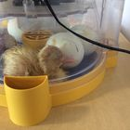

One of our staff kindly took 3 of our ducks home to live with her (the other ducks are living safely on a farm). Look how big they have grown!

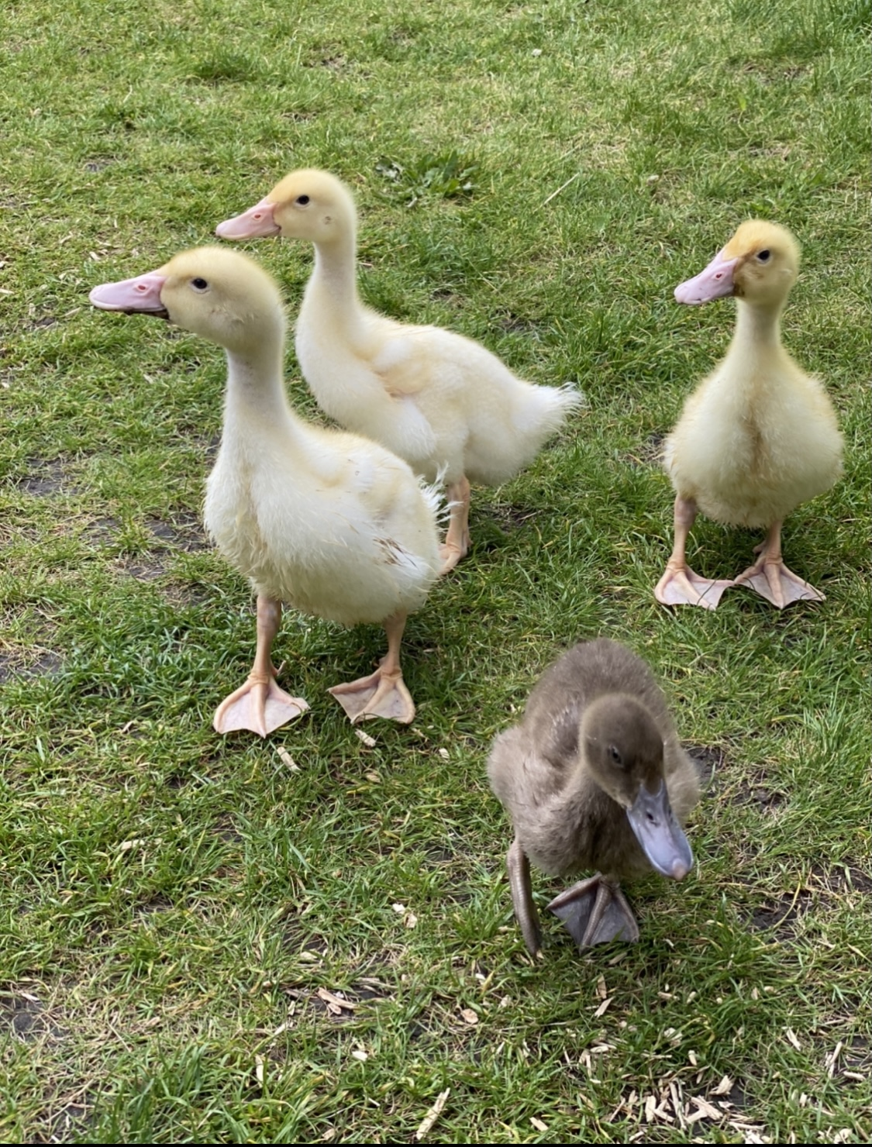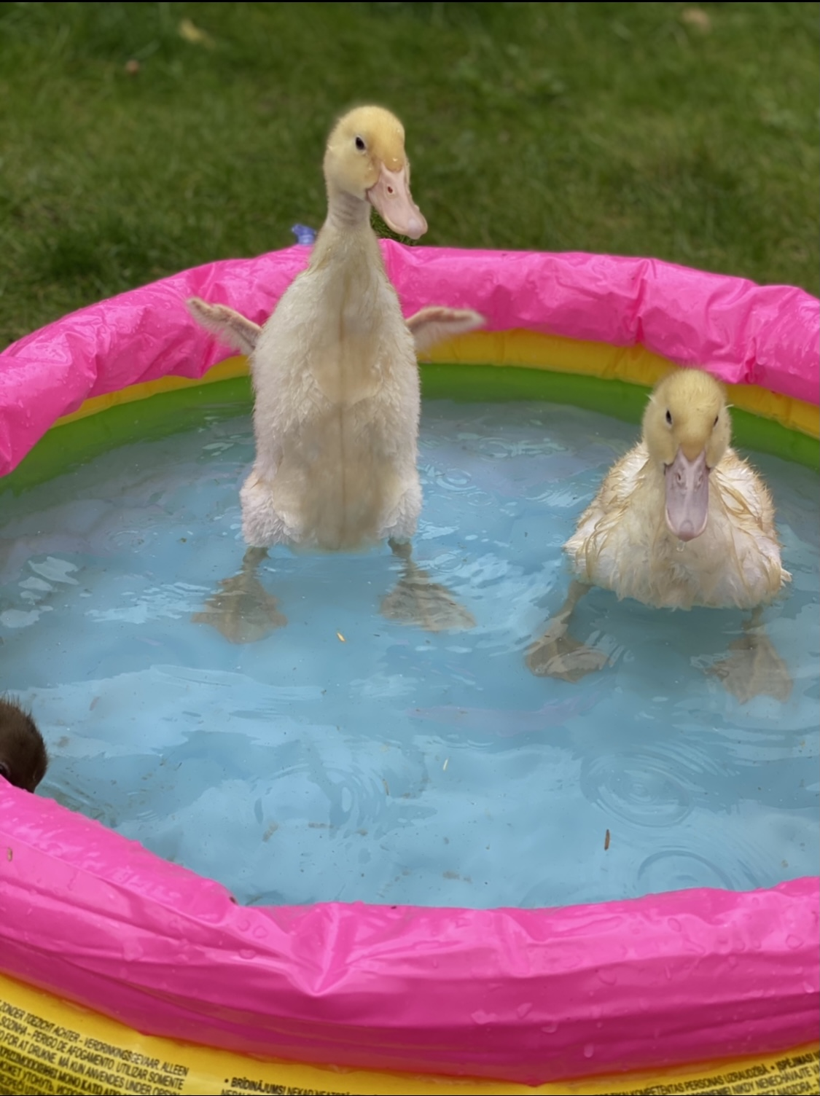
What did our pupils have to say about the ducks?
“The ducklings grew up so quickly.”
“My favourite part of having the ducklings was when one jumped onto the warming plate.”
“They had to leave our class because they are too big to keep in the classroom an​d they need to make friends on the farm.”
“My favourite part of having the ducklings was watching them grow.”
Thank you again to the Friends of Christ Church School for the opportunity.

Friends of Christ Church School
Friends of Christ Church School need you! We are still looking to form a new team of people to help continue with our fundraising campaign. In the summer term Jo and Mark will be organising some Zoom meetings to discuss FCCS and will be discussing how you can help. Whatever your skill base, there will be a supportive role for you.

Thank you to everyone who has already purchased a Christ Church School tea-towel. These should now all have been distributed. We do have some left, priced at £4 each. If you require a tea-towel, please contact the school.

We are also hoping to set up our second hand school uniform shop online soon.

Finally, a few reminders.

Despite the government already lifting some restrictions, with more due to be potentially lifted on 21st June2021, it is important to note that schools have not yet been given any advice on the lifting of restrictions. Therefore, we must continue to follow the DfE guidelines.
We will still be following our Risk Assessments to support our pupils, families and staff.
Please ensure you wear a face covering when waiting outside school and when walking through school. Please ensure you practice social distancing when queuing at collection and drop off.
Finally, please try to keep to the pick up and drop off times:

 | Drop off | Pick up
Reception, Years 3 and 4 | 8:40 | 3:00
Year 1 and 5 | 8:50 | 3:10
Years 2 and 6 | 9:00 | 3:20

If your child has symptoms of Covid-19 and subsequently tests positive, using a PCR test (we can not accept results from LFTs) within 48 hours of last being at school, please email office1@christchurch.croydon.sch.uk so we can notify contacts.

A message from our Governors
Governors have been very busy over recent months, meeting several times, both as a full board and at committee level – all virtually! The safety of children, families and staff in terms of the Covid bubble model that is in place has been carefully considered, as have school budgets, remote learning, admissions and a whole host of other issues. And of course the whole board has been delighted to welcome and work with Mrs Richardson as the new Purley Partnership Federation (PPF) Executive Head Teacher and a vital member of the governing body.
An exciting piece of work that is currently being embarked upon is defining PPF’s Mission, Vision and Values. Both Christ Church C of E Primary School and Purley Nursery School have established their own, which really encapsulate what the two settings are about and run through everything they do. Governors are keen to do the same at board level, and are aiming to have statements that describe why PPF exists (its Mission), what it is striving to do (the Vision), and the behaviours and ethos that underpin the valuable work they do (the Values).
Another significant piece of news is that Sally Marvin has been elected to succeed Asha Fowells as chair of the governing board from early May. Asha stepped into the role in January 2020 so has had a short but busy time, including overseeing the appointment of a new Executive Head and the many challenges presented by the coronavirus pandemic. With her term as parent governor due to end this summer, which coincides with her younger daughter leaving the Federation schools, the time is right for her to step down. Sally Marvin is a Foundation governor, is a retired senior level teacher and has also served on the Governing Boards of other schools, so will bring experience and expertise as hopefully school life slowly returns to normal.​

An update from Sally Marvin, Chair of Governors

I would like to take this opportunity to introduce myself to you all as the new Chair of Governors at Purley Partnership Federation. I feel privileged and excited to be taking on this role.

My background is in education. I taught for over 40 years in both maintained and independent schools, initially teaching English to secondary aged pupils and subsequently, following additional qualifications in SEND, becoming SENCO in various local comprehensive and independent schools. My last full time post was at nearby Cumnor House Boys School in Purley, where I was Head of Learning Support as well as Director of Studies (Assistant Headteacher).

From December 2015- December 2020, I was a governor at another Croydon primary school, where I was Vice Chair, Chair of the Curriculum Committee and the link governor for SEND and Pupil Premium. I was appointed as a foundation governor at Purley Partnership Federation by Christ Church PCC in March 2020, just as Covid-19 struck. I managed to meet with the other governors face to face for only one Full Governing Body meeting before all meetings were diverted to Zoom – the wonders of modern technology! My responsibilities continue to be linked to SEND and Pupil Premium, and I have been Vice Chair since September 2020.

I am a member of Purley Baptist Church where I have led Women’s Ministry and Rainbows as well as helping in the Junior Church. Currently, I co-lead a weekly Life Group Bible study. Much of my spare time is taken up with the delightful duties of being nanna to two beautiful little granddaughters and two lively little grandsons!

The governing body is continuing to implement some exciting new initiatives. Following on from the construction of Purley Partnership Federation Mission, Vision and Values statements which Asha Fowells has previously referred to, certain aspects of these statements will ultimately be incorporated into a Governance Development Plan. This Plan will identify areas for development for the governing body which will be monitored and their success recorded through the Plan. Our aim is that this process will lead to an even more effective, robust and aspirational team of governors who will continue to work together across the federation to ensure the very best education for all pupils at both Christ Church School and Purley Nursery School, and to provide support and encouragement to all federation staff members.

I am very much looking forward to the opportunity of visiting the school in person. I can’t wait to meet the children and the staff face to face, and introduce myself to as many parents and carers as possible. Let us keep hoping and praying that this might be possible very soon.

Should you need to get in touch with me at any time please feel free to contact the school office, and I will get back to you as soon as possible.

With very best wishes
Sally Marvin

