Purley Partnership Federation
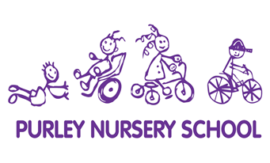
Purley Nursery School | Christ Church Primary School
Achieving and growing together | Nurturing lifelong learners with God’s guidance

Purley Nursery School, 58 Pampisford Rd, Purley CR8 2NE

Lead Nursery Class Teacher
Salary - M6 FTE salary
(This post is not suitable for an NQT)

We are looking for a passionate, enthusiastic
Early Years Class Teacher to lead our nursery team.

This role is on a fixed term contract covering maternity leave, starting September 1st 2021 duration at least six months.

Purley Nursery School is committed to safeguarding our children. We follow Safer Recruitment practices which include, but are not limited to, applying for DBS checks on all newly appointed staff.

Closing date: 17th May at 12 noon

Shortlisting date: 17th May
Interviews will take place on: 25th May

Role Description and Personal Specification

Purley Nursery School and Governors are looking to appoint an experienced, outstanding Early Years practitioner with a proven track record of working in a Local Authority maintained Nursery School.
Purley Nursery School offers a play-based, child-centred and developmentally appropriate curriculum from 8a.m. to 6 p.m. It is a fully inclusive school and integrates education and day-care across the whole day and year.
The successful candidate will have high-level understanding of the Early Years Foundation Stage and have all the necessary skills and qualities to be a key worker with full responsibility for planning and assessment for a group of 2, 3 and 4 year olds. They must have experience of leading a team and be confident to carry out staff training, moderation and develop initiatives within the school alongside the Head of School and School Development Plan.

Experience with Target Tracker for monitoring children’s attainment and progress is desirable however internal training will be provided.

This is a desirable post for candidates who are looking for opportunities in middle leadership and to develop their experience leading a team to strive for excellence.

The candidate must be hard-working, energetic and committed to high quality Early Years teaching with a can-do attitude, welcoming challenge.

For more information please contact the school office:
0208-660-5639
office@purley.croydon.sch.uk
Further information and application forms available from the school website: https://www.purleynurseryschoolcc.com/

