Diocese of Southwark
Croydon LEA
Christ Church C of E Primary School, Purley, Surrey, CR8 2QE
Group 3 NOR 420
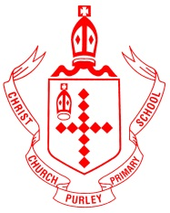

Class Teacher
Salary - Main pay range

We are looking for a part time KS2 Class Teacher to work on Fridays as part of a job share

Permanent post to start as soon as possible

We love children and care about every aspect of their development.
Our strong Christian ethos is at the heart of our strong school community.
Our hard working staff team strives to make learning fun and memorable for children.

Teachers have said:

‘We are very lucky at Christ Church to work as part of a close knit supportive team’

‘It is not until you leave something behind you realise its true value! Coming to my new school made me realise just how much I had learned at Christ Church.’

Are you an enthusiastic teacher who enjoys working with children?
Are you able to support the distinctive Christian ethos of the school?

We are a well resourced school with supportive teachers and governors and committed parents.

For more information please contact the school office:
020-8660-7500
office1@christchurch.croydon.sch.uk
Closing date: noon on 3rd December 2020

Applications are welcomed from either experienced professionals who wish to progress their career or from NQTs

Application packs can be downloaded from www.christchurch.croydon.sch.uk

Christ Church C of E Primary School is committed to safeguarding our children. We follow Safer Recruitment practices which include, but are not limited to, applying for DBS checks on all newly appointed staff.

